Biostatistics Project: A County-Level Analysis of Factor Associated with COVID-19 Infection, Hospitalization, and Mortality in Florida
Introduction
The year 2020 was marked by the worldwide spread of SARS-CoV-2, the virus that causes COVID-19, declared a pandemic disease by the World Health Organization (WHO). The speed at which the virus is transmitted has been evident in the growth and magnitude of cases registered in the world. According to WHO data, as of November 19, 2020, approximately 55 million people had become infected and more than 1.3 million had died as a result of COVID-19^{[1]}. Most illnesses result from situations in which one is born, lives, studies, works, and even has fun. This set of conditions, identified as 'social determinants of health' and mainly responsible for generating systematic differences according to different population groups, are at the essence of health inequalities^{[2]}. In the context of the state’s evident social problems, it is difficult to discuss health issues without considering the present inequalities and their consequences are evident in living and housing conditions. In view of the new coronavirus pandemic, an important relationship has been observed between multimorbidity, COVID-19 and social determinants, with individuals with the worst socioeconomic conditions being the most affected^{[3]}. The prevalence and severity of COVID-19 are closely linked to other morbidities incidents, especially among the poorest, with less education and less access to health services. In these terms, this project brings a statistical overview on the socioeconomic and demographic factors associated with infection, hospitalization, and mortality in the state of Florida at a county level.

Materials and Methods
Data and Preliminary Analysis
There were collected data on 13 explanatory variables (population size, median income, % of people below poverty, % uninsured people, % of diabetic people, % of black people, % of people living at rural areas, % of obese people, % smoking, median age, % vaccinated for the flu, % unemployed, and % overcrowding) and 3 response variables (infection rate, hospitalization rate, and death rate) from the 67 counties composing the state of Florida. The goal was to respond the following research questions: (1) “what factors are significantly associated with COVID-19 infection?”, (2) “what factors are significantly associated with COVID-19 hospitalization?”, and (3) “what factors are significantly associated with COVID-19 deaths?”. Before any analysis, the response variables were transformed into dichotomous variables based into the following criteria: if the county’s rate was above the state average in terms of infection, hospitalization, or mortality, it was coded “1”, otherwise, it was coded “0”. Then, to respond these research questions an exploratory analysis was conducted in order to understand the dynamics of both the explanatory and response variables, followed by point-biserial correlation analysis to investigate what variables presented a significant relationship with infection rate, hospitalization rate, and death rates. The relationship of the variables with the responses was evaluated through stepwise multiple logistic regression at a confidence level of 95% using the software R Studio and the following packages: “tidyverse”, “caret”, “leaps”, “MASS”, “dplyr”, “ltm”, “Hmisc”, “gmodels”, and “jtools”.
Results
By Infection Rate
Across the 67 counties of Florida, 33 were above the average infection rate in the whole state, meaning a share of approximately 49.25%. Table 1 below summarizes some statistics from the variables under analysis.
Table 1. Statistics by state’s infection rate status (below or above the average) for the demographic and socioeconomic variables
 | Below Florida’s Average Infection Rate
 |  | Mean |  | SD | Lower 95% C.I. |  | Upper 95% C.I
Population Size |  | 392441.2 |  | 404403.1 | 251338.26 |  | 533544.09
Median Income |  | 56683.38 |  | 10378.52 | 50062.15 |  | 57304.62
%Below Poverty |  | 12.02 |  | 5.47 | 10.11 |  | 13.92
%Uninsured People |  | 19.02 |  | 3.88 | 17.66 |  | 20.37
%Diabetic People |  | 12.42 |  | 3.15 | 11.31 |  | 13.52
% Black People |  | 10.17 |  | 4.74 | 8.52 |  | 11.82
% Rural People |  | 22.17 |  | 25.21 | 13.37 |  | 30.96
% Obese People |  | 28.60 |  | 4.99 | 26.85 |  | 30.34
% Smoking |  | 17.73 |  | 2.90 | 16.72 |  | 18.75
Median Age |  | 43.18 |  | 7.05 | 40.72 |  | 45.64
% Vaccinated – Flu |  | 42.62 |  | 5.62 | 40.66 |  | 44.58
% Unemployed |  | 3.81 |  | 0.61 | 3.59 |  | 4.02
% Overcrowding |  | 2.24 |  | 0.94 | 1.91 |  | 2.56
 | Above Florida’s Average Infection Rate
 |  | Mean |  | SD | Lower 95% C.I. |  | Upper 95% C.I
Population Size |  | 245336.4 |  | 596631.7 | 33779.97 |  | 456892.75
Median Income |  | 47468.06 |  | 9054.20 | 44257.58 |  | 50678.54
%Below Poverty |  | 12.34 |  | 4.39 | 10.78 |  | 13.89
%Uninsured People |  | 18.65 |  | 4.46 | 17.07 |  | 20.23
%Diabetic People |  | 13.15 |  | 2.72 | 12.19 |  | 14.11
% Black People |  | 18.23 |  | 11.03 | 14.32 |  | 22.14
% Rural People |  | 53.30 |  | 31.36 | 42.18 |  | 64.42
% Obese People |  | 33.85 |  | 4.71 | 32.17 |  | 35.52
% Smoking |  | 20.69 |  | 2.23 | 19.90 |  | 21.49
Median Age |  | 42.45 |  | 3.11 | 41.35 |  | 43.56
% Vaccinated – Flu |  | 35.33 |  | 5.65 | 33.33 |  | 37.34
% Unemployed |  | 3.78 |  | 0.63 | 3.56 |  | 4.00
% Overcrowding |  | 3.21 |  | 1.72 | 2.60 |  | 3.82
Point-Biserial Correlations |  |  | r |  |  | p-value
Population Size |  |  | -0.145 |  |  | 0.241
Median Income |  |  | -0.308 |  |  | 0.011
%Below Poverty |  |  | 0.033 |  |  | 0.792
%Uninsured People |  |  | -0.045 |  |  | 0.720
%Diabetic People |  |  | 0.123 |  |  | 0.310
% Black People |  |  | 0.436 |  |  | 0.000
% Rural People |  |  | 0.486 |  |  | 0.000
% Obese People |  |  | 0.481 |  |  | 0.000
% Smoking |  |  | 0.501 |  |  | 0.000
Median Age |  |  | -0.067 |  |  | 0.591
% Vaccinated – Flu |  |  | -0.549 |  |  | 0.000
% Unemployed |  |  | -0.021 |  |  | 0.865
% Overcrowding |  |  | 0.337 |  |  | 0.005

As observed, the confidence intervals and point biserial correlation coefficients with associated p-values suggest that a significant relationship exists between the status of infection rate (below or above the state’s mean) and the variables median income, % of black people, % of rural people, % of obese people, % smoking, % vaccinated for the Flu, and % overcrowding. Therefore, there was proposed a stepwise multiple logistic regression model with these variables in order to obtain the best model by subsetting these variables (Figure 1).
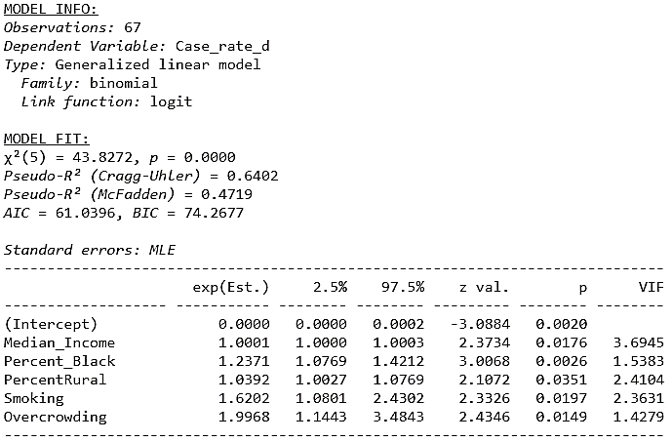
Figure 1. Stepwise multiple logistic regression over COVID-19 infection rate in Florida
Statistics from the model, χ² (5, N = 67) = 43.83, p < 0.0001, pseudo-R² = 0.6402, suggest that the model is significant and could be used for prediction of cases since there was an improvement of 64.02% in the prediction between the version of the model with only the intercept the only with the best smallest AIC/BIC values. In terms of the coefficients, we notice that all predictors were statistically significant. Moreover, the odds ratio associated with 1 year of age is 1 thus there is not really a chance (0.02%) of infection based on the age of a person, nor does for whether a person lives in rural area (1.0392 or 3.70%). On the other hand, the odds ratio of infection among black people was 1.2371 therefore they are 17.55% more likely to get infected than the other races. Those who smoke also are vulnerable and the model suggests an odds ratio of 1.6202 (or a chance 32.55% higher) that they will get infected. Finally, and as expected, overcrowding was associated to the largest odds ratio of 1.9968 that is associated with a chance of 40.88% that one would get infected in Florida if in overcrowded counties.
By Hospitalization Rates
Across the 67 counties of Florida, 29 were above the average infection rate in the whole state, meaning a share of approximately 43.28%. Table 2 below summarizes some statistics from the variables under analysis.
Table 2. Statistics by state’s hospitalization rate status (below or above the average) for the demographic and socioeconomic variables
 | Below Florida’s Average Hospitalization Rate
 |  | Mean |  | SD | Lower 95% C.I. |  | Upper 95% C.I
Population Size |  | 434486.80 |  | 572190.80 | 246412.40 |  | 622561.28
Median Income |  | 54757.63 |  | 10534.72 | 51294.96 |  | 58220.31
%Below Poverty |  | 10.69 |  | 4.49 | 9.22 |  | 12.17
%Uninsured People |  | 17.81 |  | 3.21 | 16.75 |  | 18.86
%Diabetic People |  | 11.77 |  | 2.59 | 10.92 |  | 12.63
% Black People |  | 11.99 |  | 7.81 | 9.42 |  | 14.56
% Rural People |  | 29.37 |  | 30.80 | 19.25 |  | 39.50
% Obese People |  | 28.72 |  | 4.95 | 27.09 |  | 30.34
% Smoking |  | 18.18 |  | 2.91 | 17.22 |  | 19.14
Median Age |  | 42.66 |  | 6.28 | 40.59 |  | 44.72
% Vaccinated – Flu |  | 40.45 |  | 7.47 | 37.99 |  | 42.90
% Unemployed |  | 3.59 |  | 0.50 | 3.42 |  | 3.75
% Overcrowding |  | 2.43 |  | 1.08 | 2.07 |  | 2.78
 | Above Florida’s Average Hospitalization Rate
 |  | Mean |  | SD | Lower 95% C.I. |  | Upper 95% C.I
Population Size |  | 169951.70 |  | 372511.10 | 28256.09 |  | 311647.36
Median Income |  | 45203.14 |  | 6592.77 | 42695.38 |  | 47710.89
%Below Poverty |  | 14.11 |  | 4.89 | 12.26 |  | 15.97
%Uninsured People |  | 20.19 |  | 4.86 | 18.34 |  | 22.04
%Diabetic People |  | 14.09 |  | 2.90 | 12.99 |  | 15.20
% Black People |  | 16.96 |  | 10.45 | 12.98 |  | 20.93
% Rural People |  | 48.15 |  | 31.49 | 36.17 |  | 60.13
% Obese People |  | 34.41 |  | 4.45 | 32.72 |  | 36.11
% Smoking |  | 20.51 |  | 2.54 | 19.55 |  | 21.48
Median Age |  | 43.03 |  | 4.21 | 41.43 |  | 44.64
% Vaccinated – Flu |  | 37.17 |  | 5.04 | 35.25 |  | 39.09
% Unemployed |  | 4.06 |  | 0.66 | 3.81 |  | 4.31
% Overcrowding |  | 3.09 |  | 1.79 | 2.41 |  | 3.77
Point-Biserial Correlations |  |  | r |  |  | p-value
Population Size |  |  | -0.259 |  |  | 0.034
Median Income |  |  | -0.469 |  |  | 0.000
%Below Poverty |  |  | 0.346 |  |  | 0.004
%Uninsured People |  |  | 0.286 |  |  | 0.019
%Diabetic People |  |  | 0.393 |  |  | 0.001
% Black People |  |  | 0.266 |  |  | 0.029
% Rural People |  |  | 0.291 |  |  | 0.017
% Obese People |  |  | 0.517 |  |  | 0.000
% Smoking |  |  | 0.392 |  |  | 0.001
Median Age |  |  | 0.035 |  |  | 0.782
% Vaccinated – Flu |  |  | -0.244 |  |  | 0.046
% Unemployed |  |  | 0.387 |  |  | 0.001
% Overcrowding |  |  | 0.228 |  |  | 0.064

As observed, the confidence intervals and point biserial correlation coefficients with associated p-values suggest that a significant relationship exists between the status of hospitalization rate (below or above the state’s mean) and the all the proposed variables with exception of median age and % of overcrowding. Therefore, there was proposed a stepwise multiple logistic regression model with these variables in order to obtain the best model by subsetting these variables (Figure 2).
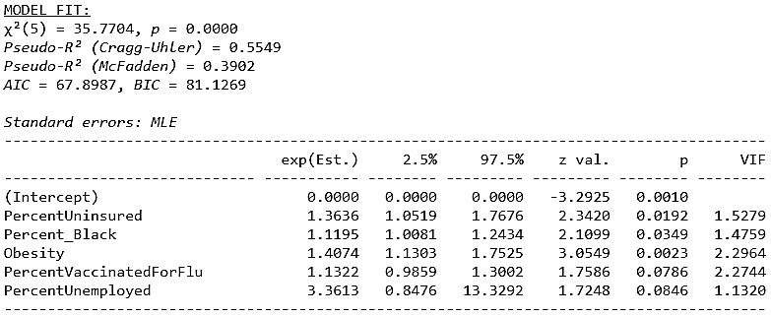
Figure 2. Stepwise multiple logistic regression over COVID-19 hospitalization rate in Florida
Statistics from the model, χ² (5, N = 67) = 35.77, p < 0.0001, pseudo-R² = 0.5549, suggest that the model is significant and could be used for prediction of cases since there was an improvement of 55.49% in the prediction between the version of the model with only the intercept the only with the best smallest AIC/BIC values. In terms of the coefficients, we notice that all predictors were statistically significant with exception to the % of vaccinated people and % unemployed. Thus, the odds ratio associated with 1% increase in uninsured people in the population is 1.3636, i.e., they are 23.67% more likely to get hospitalized. The odds ratio of hospitalization among black people was 1.1195 or 10.15% more likely to get hospitalized than the other races. Those who are obese also are vulnerable and the model suggests an odds ratio of 1.4074 (or a chance 25.47% higher) that they will get hospitalized compared to non-obese people.
By Death Rates
Across the 67 counties of Florida, 31 were above the average death rate in the whole state, meaning a share of approximately 46.27%. Table 3 below summarizes some statistics from the variables under analysis.
Table 2. Statistics by state’s death rate status (below or above the average) for the demographic and socioeconomic variables
 | Below Florida’s Average Death Rate
 |  | Mean |  | SD | Lower 95% C.I. |  | Upper 95% C.I
Population Size |  | 391513.90 |  | 461483.30 | 235370.40 |  | 547657.38
Median Income |  | 54831.69 |  | 10558.97 | 51259.05 |  | 58404.34
%Below Poverty |  | 11.81 |  | 5.41 | 9.98 |  | 13.64
%Uninsured People |  | 18.03 |  | 3.96 | 16.69 |  | 19.38
%Diabetic People |  | 11.86 |  | 2.88 | 10.89 |  | 12.84
% Black People |  | 13.16 |  | 8.23 | 10.37 |  | 15.94
% Rural People |  | 29.26 |  | 31.18 | 18.71 |  | 39.81
% Obese People |  | 30.09 |  | 5.19 | 28.34 |  | 31.85
% Smoking |  | 18.12 |  | 2.80 | 17.17 |  | 19.07
Median Age |  | 42.33 |  | 6.05 | 40.29 |  | 44.38
% Vaccinated – Flu |  | 40.50 |  | 6.40 | 38.33 |  | 42.67
% Unemployed |  | 3.60 |  | 0.56 | 3.41 |  | 3.79
% Overcrowding |  | 2.56 |  | 1.27 | 2.13 |  | 2.99
 | Above Florida’s Average Death Rate
 |  | Mean |  | SD | Lower 95% C.I. |  | Upper 95% C.I
Population Size |  | 236922.60 |  | 556727.90 | 32713.15 |  | 441132.01
Median Income |  | 45733.55 |  | 7173.50 | 43102.29 |  | 48364.81
%Below Poverty |  | 12.60 |  | 4.37 | 10.99 |  | 14.20
%Uninsured People |  | 19.77 |  | 4.22 | 18.22 |  | 21.32
%Diabetic People |  | 13.84 |  | 2.69 | 12.86 |  | 14.83
% Black People |  | 15.28 |  | 10.44 | 11.45 |  | 19.11
% Rural People |  | 47.07 |  | 31.28 | 35.60 |  | 58.55
% Obese People |  | 32.45 |  | 5.66 | 30.37 |  | 34.52
% Smoking |  | 20.44 |  | 2.71 | 19.44 |  | 21.43
Median Age |  | 43.39 |  | 4.69 | 41.67 |  | 45.11
% Vaccinated – Flu |  | 37.32 |  | 6.71 | 34.86 |  | 39.78
% Unemployed |  | 4.02 |  | 0.62 | 3.79 |  | 4.24
% Overcrowding |  | 2.90 |  | 1.64 | 2.29 |  | 3.50
Point-Biserial Correlations |  |  | r |  |  | p-value
Population Size |  |  | -0.152 |  |  | 0.218
Median Income |  |  | -0.449 |  |  | 0.000
%Below Poverty |  |  | 0.080 |  |  | 0.519
%Uninsured People |  |  | 0.21 |  |  | 0.088
%Diabetic People |  |  | 0.338 |  |  | 0.005
% Black People |  |  | 0.115 |  |  | 0.355
% Rural People |  |  | 0.277 |  |  | 0.023
% Obese People |  |  | 0.215 |  |  | 0.080
% Smoking |  |  | 0.391 |  |  | 0.001
Median Age |  |  | 0.097 |  |  | 0.434
% Vaccinated – Flu |  |  | -0.239 |  |  | 0.052
% Unemployed |  |  | 0.34 |  |  | 0.005
% Overcrowding |  |  | 0.118 |  |  | 0.343

As observed, the confidence intervals and point biserial correlation coefficients with associated p-values suggest that a significant relationship exists between the status of hospitalization rate (below or above the state’s mean) and the all the proposed variables with exception of population size, % below poverty, % of uninsured people, % black people, % of obese people, median age, % of vaccinated for flu, and % overcrowding. Therefore, there was proposed a stepwise multiple logistic regression model with these variables in order to obtain the best model by subsetting these variables (Figure 3).
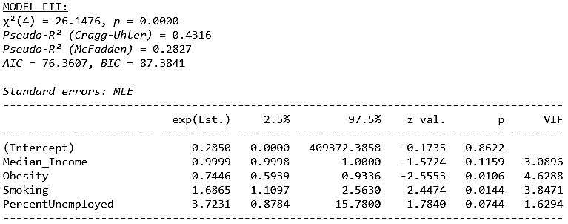
Figure 3. Stepwise multiple logistic regression over COVID-19 death rate in Florida
Statistics from the model, χ² (4, N = 67) = 26.15, p < 0.0001, pseudo-R² = 0.4316, suggest that the model is significant and could be used for prediction of cases since there was an improvement of 43.16% in the prediction between the version of the model with only the intercept the only with the best smallest AIC/BIC values. In terms of the coefficients, we notice that all predictors were statistically significant with exception to the median income and % unemployed. Thus, the odds ratio associated with 1% increase in obesity in the population is 0.7446, i.e., they are 41.82% less likely to die due to COVID-19. The odds ratio of hospitalization among those who smoke is 1.6865 or 34.33% more likely to die due to COVID-19 than no smokers.

Conclusion
Based on the findings at county-level in the whole state of Florida, the factors most influent on COVID-19 infection are (1) median income, (2) % of black people in the state, (3) % of rural people in the state, (4) % of smoking, and (5) % of overcrowding. Moreover, the factors influencing hospitalization are (1) % of people uninsured, (2) % of black people, and (3) % of obesity. Furthermore, the factors most influent on death by COVID-19 are (1) obesity and (2) % of smoking. With this scenario, it is possible to conclude that it takes a lot more of external variables to get one just infected by the virus than the termination in death. Further research should be carried out using other variables that might also affect these outcomes.
References
- Pan American Health Organization. Fact sheet: COVID-19 [Internet]. Brasília, DF: PAHO; [2020] [access 02 Dec. 2021]. Available at: http://www.paho.org/pt/covid19.
- World Health Organization. Coronavirus disease (COVID-19): situation reports [Internet]. Geneva: WHO; [2020] [access 02 Dec. 2021]. Available at: https://www.who.int/emergencies/diseases/novel-coronavirus-2019/situation-reports.
- Fang X, Li S, Yu H, Wang P, Zhang Y, Chen Z, et al. Epidemiological, comorbidity factors with severity and prognosis of COVID-19: a systematic review and meta-analysis. Aging (Albany NY). 2020 Jul 13;12(13):12493-503. doi: http://dx.doi.org/10.18632/aging.103579. Epub 2020 Jul 13.

